#include <iostream>

using namespace std;

class Account {

public:

Account() {

id = 0;

balance = 0;

annualInterestRate = 0;

}

Account(int i, double bal, double rate) {

id = i;

balance = bal;

annualInterestRate = rate;

}

// Set (mutator) and get (accessor) functions

void setId(int i) {

id = i;

}

void setBalance(double b) {

balance = b;

}

void setAnnualInterestRate(double a) {

annualInterestRate = a;

}

double getMonthlyInterestRate() {

double monthlyInterestRate = annualInterestRate / 1200;

return monthlyInterestRate;

}

double getBalance() {

return balance;

}

int getId() {

return id;

}

void withdraw(double amount) {

if (amount > balance) {

cout << "Sorry you have an insufficient balance\n";

} else {

balance = balance - amount;

}

}

void deposit(double amount) {

balance = balance + amount;

}

private:

int id;

double balance;

double annualInterestRate;

};

int main() {

int id = 1122;

double balance = 20000;

double annualInterestRate = 4.5;

Account a(id, balance, annualInterestRate);

cout << endl << "After your withdraw $2500. ";

a.withdraw(2500);

cout << "Balance is: $" << a.getBalance();

a.deposit(3000);

cout << endl;

cout << "After your deposit of $3000. Your balance is: $" << a.getBalance();

cout << endl;

cout << "The monthly interest rate is: " << a.getMonthlyInterestRate() << endl;

}

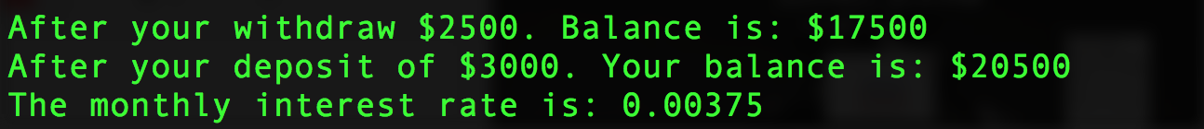

#include <iostream>

#include <string>

using namespace std;

bool isPalindrome(const string& s);

int main() {

string str;

cout << "Please enter a string: ";

getline(cin, str);

bool palindrome = isPalindrome(str);

if (palindrome) {

cout << str << " is a palindrome" << endl;

} else {

cout << str << " is not a palindrome" << endl;

}

}

bool isPalindrome(const string& s) {

bool palindrome = true;

for (int i = 0; i< s.length(); i++) {

if (toupper(s[i]) != toupper(s[s.length()-1-i])) {

palindrome = false;

}

}

return palindrome;

}

